Q47. Longest Alternating Subsequence Given an array, find the length of the longest subsequence such that the differences between successive elements alternate between positive and negative. The sequence must maintain the original order. The goal is to maximize the subsequence length. Use Dynamic Programming to solve the problem.
Input Format:
n = number of elements
arr[] = elements
Sample Input:
n = 6
arr = 1 5 4 9 2 5
Expected Output:
Length = 6
1.REPORT:
Longest Alternating Subsequence

Aim
To find the length of the Longest Alternating Subsequence (LAS) using Dynamic Programming.

Problem Statement
Given an array of integers, find the length of the longest subsequence such that the differences between consecutive elements alternate between positive and negative. The subsequence must maintain the original order of elements.

Algorithm
- Read the number of elements n.
- Read the array elements.
- Create two arrays:
  - up[i]: Length of the longest alternating subsequence ending at index i with a positive difference.
  - down[i]: Length of the longest alternating subsequence ending at index i with a negative difference.
- Initialize all elements of up and down to 1.
- Compare every pair of elements:
  - If arr[i] > arr[j], update up[i] = max(up[i], down[j] + 1).
  - If arr[i] < arr[j], update down[i] = max(down[i], up[j] + 1).
- The answer is the maximum value in both arrays.
- Display the result.

Python Code
def longest_alternating_subsequence(arr):
n = len(arr)
up = [1] * n
down = [1] * n
for i in range(1, n):
for j in range(i):
if arr[i] > arr[j]:
up[i] = max(up[i], down[j] + 1)
elif arr[i] < arr[j]:
down[i] = max(down[i], up[j] + 1)
return max(max(up), max(down))
# Input
n = int(input("Enter number of elements: "))
arr = list(map(int, input("Enter array elements: ").split()))
# Output
print("Length =", longest_alternating_subsequence(arr))

Sample Input
Enter number of elements: 6
Enter array elements: 1 5 4 9 2 5

Sample Output
Length = 6

Time Complexity
- Time: O(n²)
- Space: O(n)

Result
The program successfully finds the Longest Alternating Subsequence using Dynamic Programming and outputs the maximum subsequence length while maintaining the original order of the elements.

2.OUTPUT:
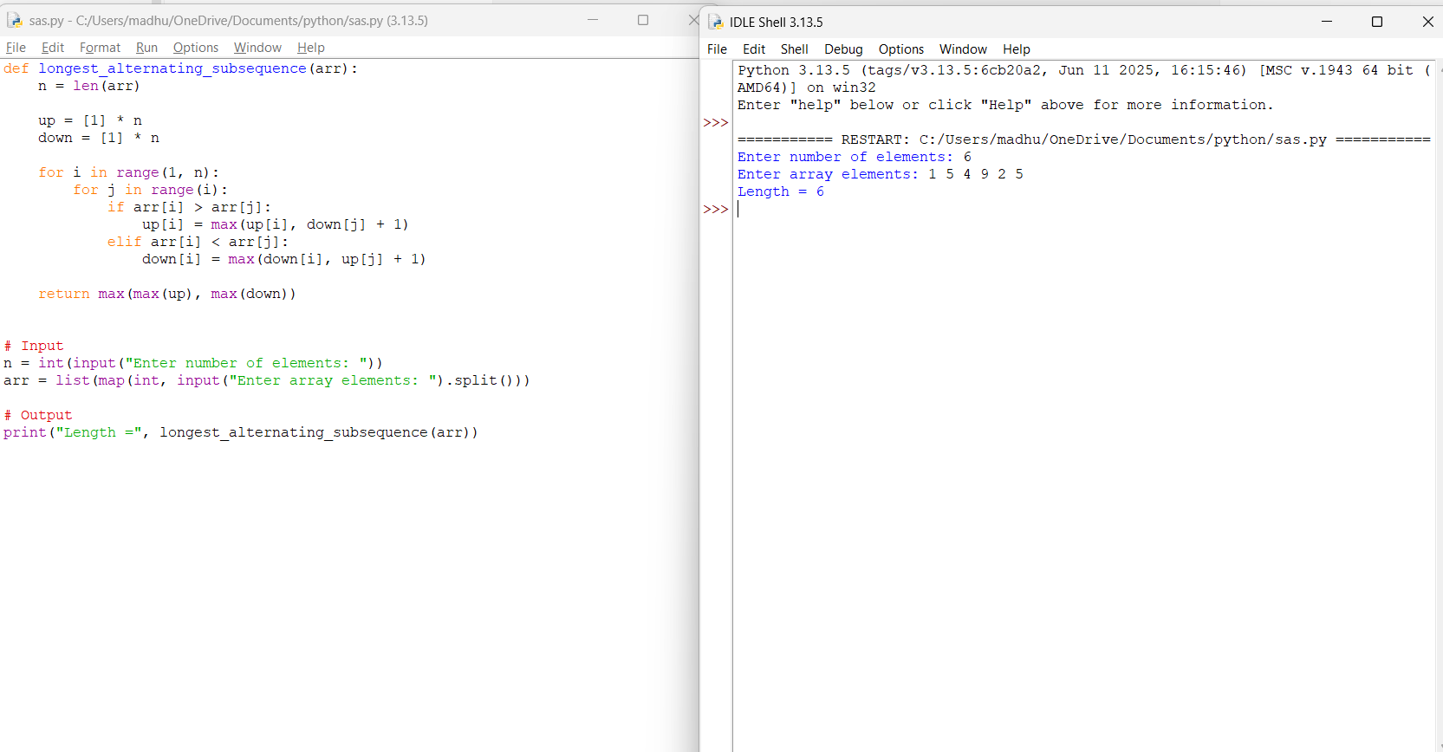

Q11. Longest Common Subsequence (LCS)
Two strings are given, and the task is to find the longest subsequence that appears in both
strings in the same relative order. The characters of the subsequence need not be contiguous,
but the sequence order must be preserved. The objective is to compute the maximum possible
length of such a common subsequence. Use Dynamic Programming to determine the optimal
result efficiently.
Input Format:
s1 = first string
s2 = second string
Sample Input:
s1 = ABCDGH
s2 = AEDFHR
Expected Output:
LCS Length = 3

1.REPORT:
Longest Common Subsequence (LCS)

Aim
To find the Longest Common Subsequence (LCS) between two strings using Dynamic Programming.

Problem Statement
Given two strings, find the length of the Longest Common Subsequence (LCS). A subsequence appears in the same relative order in both strings but the characters need not be contiguous. Use Dynamic Programming to efficiently compute the maximum possible length of the common subsequence.

Algorithm
- Read the two input strings s1 and s2.
- Let m and n be the lengths of s1 and s2.
- Create a DP table of size (m+1) × (n+1) initialized with 0.
- Traverse both strings:
  - If s1[i-1] == s2[j-1], then dp[i][j] = dp[i-1][j-1] + 1.
  - Otherwise, dp[i][j] = max(dp[i-1][j], dp[i][j-1]).
- The value at dp[m][n] gives the length of the Longest Common Subsequence.
- Display the result.

Python Code
def lcs(s1, s2):
m = len(s1)
n = len(s2)
dp = [[0] * (n + 1) for _ in range(m + 1)]
for i in range(1, m + 1):
for j in range(1, n + 1):
if s1[i - 1] == s2[j - 1]:
dp[i][j] = dp[i - 1][j - 1] + 1
else:
dp[i][j] = max(dp[i - 1][j], dp[i][j - 1])
return dp[m][n]
# Input
s1 = input("Enter first string: ")
s2 = input("Enter second string: ")
# Output
print("LCS Length =", lcs(s1, s2))

Sample Input
Enter first string: ABCDGH
Enter second string: AEDFHR

Sample Output
LCS Length = 3

Time Complexity
- Time Complexity: O(m × n)
- Space Complexity: O(m × n)
where:
- m = length of the first string
- n = length of the second string

Result
The program successfully computes the Longest Common Subsequence (LCS) using Dynamic Programming and outputs the maximum common subsequence length. For the sample input ABCDGH and AEDFHR, the LCS Length = 3.
2.OUTPUT:
